Defining Classes Labs – Part 1

1. 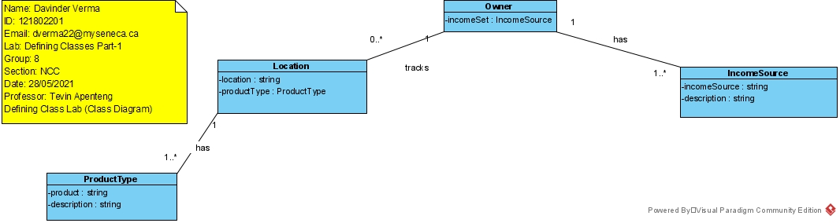Create a class diagram to support the case study and Systems Use Case Specifications
2. Create object level sequence diagrams – one for each of the Query use cases. (3 object level sequence diagrams)